Practicum Case | 
COMP7116 | COMP7116001 | COMP7116016 | MATH6168 | MATH6168016
Computer Vision
Computer Science | O221-COMP7116-NC01-04
Valid on Odd Semester 2024/2025 | Revision 00

Learning Outcome
- LO1 – Describe various computational principles and standard image processing operators in computer vision

Topic
- Session 4 – Edge Detection

Sub Topics
- Canny
- Sobel
- Laplace
- Edge Visualization

Soal
Case
SeNaCony
Recently, a very popular game just released a new map called SeNaCony which brings all kinds of people to try out the new map. Currently, the developers are having difficulties in advertising the new map using their official artworks and felt like the artworks needs some adjustments, which leads to them asking for your help to make a program using Python for Edge Detection. This program can help them identify what can be improved from the artwork, such as the brightness of the artwork changing sharply, and can also enhance the artwork.
- Canny
- Make a program that can perform edge detection using the Canny algorithm.
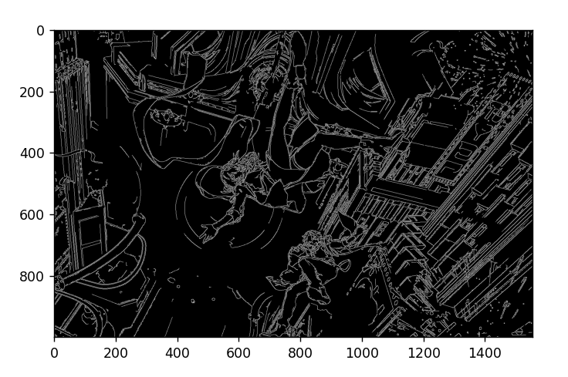
Figure 1. Example of Edge Detection using Canny
- Sobel
- Make a program that can perform edge detection using the Sobel algorithm for both horizontal and vertical directions to the greyscale image.

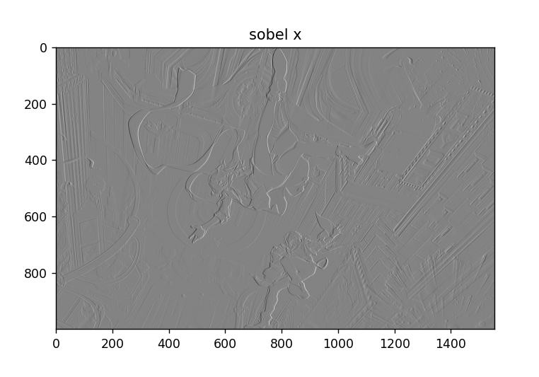
Figure 2. Example of Edge Detection using Sobel (Horizontal)
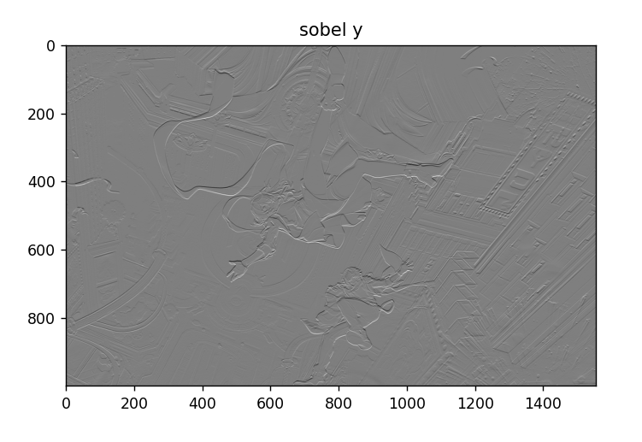
Figure 3. Example of Edge Detection using Sobel (Vertical)
- Laplace
- Make a program that can perform edge detection using the Laplace algorithm.
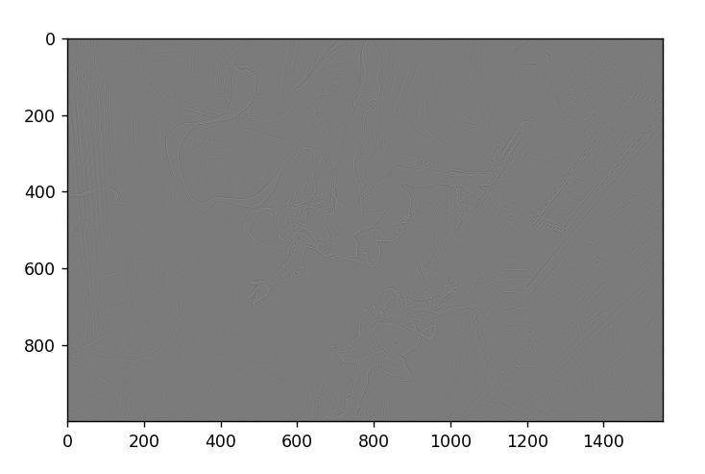
Figure 4. Example of Edge Detection using Laplace

